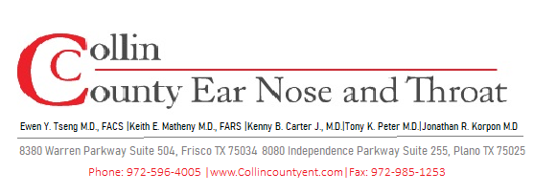
POST-OPERATIVE INSTRUCTIONS
Tonsillectomy
Surgical Removal of the Tonsils

WHAT TO EXPECT AFTER SURGERY

- Throat pain is expected and often WORSENS around days 5–7 as scabs form and begin to shed — this is normal.
- Pain may radiate to the ears — this is referred pain from the throat, not an ear infection.
- A white or yellowish coating at the surgical site is normal healing tissue, not infection.
- Low-grade fever (under 101°F) in the first few days is common.
- Bad breath is expected as wounds heal — this will resolve on its own.
- Most adults need 10–14 days off work; children can typically return to school in 7–10 days.

DIET & HYDRATION — MOST IMPORTANT PART OF RECOVERY

Staying Hydrated Is Critical — Dehydration Is the #1 Reason for Post-Op ER Visits
- Drink cool fluids frequently throughout the day: water, diluted juice, Pedialyte, popsicles, smoothies.
- Begin with cold, soft foods: ice cream, yogurt, pudding, mashed potatoes, scrambled eggs, applesauce.
- Advance diet as tolerated — most patients return to normal diet by 2 weeks.
- AVOID: hot foods or liquids, crunchy/hard foods (chips, crackers, toast), citrus, spicy foods.
- AVOID: straws — the suction can dislodge clots and cause bleeding.
- Eat and drink even when it hurts — hydration helps prevent complications.

PAIN MANAGEMENT

- Take pain medication on a schedule (not just when pain is severe) for the first 5–7 days.
- Acetaminophen (Tylenol) and/or ibuprofen (Motrin) are typically used alternately as directed.
- If narcotic medication is prescribed, use only as needed; do NOT combine with alcohol or sedatives.
- A cool-mist humidifier in the bedroom may ease throat discomfort overnight.
- Some patients find sleeping slightly upright more comfortable for the first few nights.

ACTIVITY & RESTRICTIONS

OK During Recovery  - Rest and light activity at home  - Watching TV, reading, quiet play (children)  - Short walks once feeling up to it  - Showering normally | Avoid for 2 Weeks  - Strenuous activity, running, sports  - Heavy lifting or straining  - Daycare / school during first week  - Large social gatherings (infection risk)  - Air travel (without surgeon clearance)

WHEN TO CALL OUR OFFICE

⚠ Call 911 or Go to the ER Immediately For:
- ANY active bleeding from the mouth or throat — do not wait.
- Breathing difficulty or noisy breathing that is worsening.
- Inability to swallow any liquids for more than 8 hours (sign of dehydration).
- Fever over 102°F that does not respond to acetaminophen.
- Signs of dehydration: no tears, no urination for 8+ hours (children), extreme dizziness.

Also Contact Our Office For:
- Pain that is not controlled with prescribed medications.
- Concerns about the appearance of the healing site.
- Small spots of blood (pink-tinged saliva) — notify us so we can advise appropriately.

FOLLOW-UP CARE

- Post-operative visit scheduled at 1-2 weeks after surgery.
- Scabs typically fall off between days 7–10 — you may notice a brief increase in pain or small spots of blood at that time.
- Contact us immediately if you see bright red bleeding at any point — this is a medical emergency.

Questions or Concerns? We Are Here to Help.
Office/After Hours: 972-596-4005
For emergencies or severe symptoms, go to the nearest Emergency Room.

