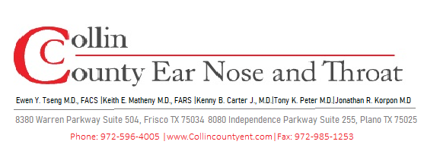
POST-OPERATIVE INSTRUCTIONS
Thyroidectomy
Total or Partial Surgical Removal of the Thyroid Gland
WHAT TO EXPECT AFTER SURGERY

- Mild to moderate throat discomfort and neck soreness is normal for 1–2 weeks.
- Swallowing may feel tight or uncomfortable for several days — this is due to swelling and will improve.
- Your voice may be hoarse or weak for days to weeks due to proximity of the recurrent laryngeal nerve. This is usually temporary.
- A small, horizontal incision at the base of the neck is expected; it typically heals to a fine scar.
- Mild swelling and firmness around the incision site is normal during healing.

INCISION CARE

Wound Care Instructions
- Keep the incision dry for 48 hours after surgery.
- After 48 hours: gently clean with mild soap and water; pat dry.
- Protect the scar from sun exposure for 6–12 months using sunscreen (SPF 30+) or clothing.
- Do not submerge the incision in water (pools, hot tubs, baths) until fully healed.

THYROID HORMONE REPLACEMENT

- If you had a total thyroidectomy, you will require lifelong thyroid hormone replacement (levothyroxine/Synthroid).
- Begin thyroid medication as prescribed — take on an empty stomach, 30–60 minutes before food.
- Do not take calcium supplements, iron, or antacids within 4 hours of your thyroid medication.
- Partial thyroidectomy patients: labs will determine whether hormone replacement is needed.

ACTIVITY & RESTRICTIONS

OK to Resume  - Light walking starting day 1  - Showering after 48 hours (avoid direct stream on incision)  - Driving once off narcotic pain medication and able to turn neck comfortably  - Desk work at 1–2 weeks | Avoid for 2–4 Weeks  - Heavy lifting (>10 lbs) or straining  - Strenuous exercise or contact sports  - Submerging incision in water  - Neck stretching or massage over incision  - Tight necklaces or collars over scar

VOICE & SWALLOWING

- Temporary hoarseness or a weak voice is common — this usually resolves within 2–6 weeks.
- Voice changes lasting beyond 6–8 weeks should be reported to your surgeon.
- If you experience difficulty breathing in addition to voice changes, seek emergency care immediately.

WHEN TO CALL OUR OFFICE

⚠ Contact Us Immediately or Go to the ER For:
- Numbness/tingling or muscle cramping (signs of low calcium — see above).
- Rapidly expanding neck swelling or sensation of choking/pressure.
- Significant bleeding or wound opening at the incision site.
- Fever over 101.5°F beyond 48 hours post-op.
- Sudden difficulty breathing or stridor (high-pitched sound when breathing).
- Hoarseness that worsens after initial improvement, or complete loss of voice.

FOLLOW-UP CARE

- First post-op visit: 1–2 weeks after surgery for wound check and symptom review.
- If surgical pathology was performed, final results will be reviewed at post-op visit.
- Ongoing endocrinology follow-up may be recommended depending on underlying thyroid condition.
- Monitoring thyroid labs required for patients on hormone replacement for life.

Questions or Concerns? We Are Here to Help.
Office/After Hours: 972-596-4005
For emergencies or severe symptoms, go to the nearest Emergency Room.

