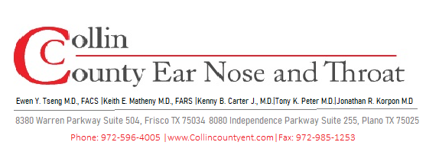
POST-OPERATIVE INSTRUCTIONS
Sinus Surgery
Functional Endoscopic Sinus Surgery (FESS)

WHAT TO EXPECT AFTER SURGERY

- Nasal congestion and stuffiness are normal for 1–3 weeks as swelling subsides.
- Mild to moderate facial pressure, headache, or fatigue is expected for the first week.
- Blood-tinged nasal drainage or dripping is normal for several days. Use gauze drip pad as needed.
- Crusting and debris inside the nose will be cleared at your post-op visit — do not pick or blow forcefully.
- Reduced or absent sense of smell is temporary and typically improves over weeks.
- Plan to take at least 5-7 days off work (longer for physically demanding jobs).

NASAL HYGIENE — CRITICAL FOR HEALING

Saline Rinses — Start Day 1 After Surgery
- Use a large-volume saline rinse (e.g., NeilMed Sinus Rinse or similar) 2–3 times daily.
- Begin the morning after surgery unless your surgeon specifies otherwise.
- Irrigate gently — do not forcefully squeeze the bottle.
- Continue rinses for at least 4–6 weeks or as directed.
- Rinse BEFORE applying any nasal steroid spray (if prescribed).

ACTIVITY & RESTRICTIONS

OK to Resume  - Light walking immediately  - Showering after 24 hours  - Driving once off narcotic pain medication  - Desk work / light activity after 5–7 days | Avoid for 2 Weeks  - Blowing your nose forcefully  - Strenuous exercise / heavy lifting (>10 lbs)  - Bending over at the waist  - Swimming or submerging the head  - Air travel (unless cleared by surgeon)

MEDICATIONS

- Take prescribed antibiotics for the full course.
- Use prescribed nasal steroid spray as directed — start after first saline rinse of the day.
- Acetaminophen (Tylenol) is preferred for pain. Avoid ibuprofen/aspirin/NSAIDs for 2 weeks (increases bleeding risk).
- Narcotic pain medication (if prescribed): use only as needed, take with food, and avoid driving.
- Use 2-3 sprays Afrin (oxymetazoline) every 2 hours as needed for bleeding. Max 3 days.

WHEN TO CALL OUR OFFICE

⚠ Contact Us Immediately If You Experience:
- Bright red bleeding that does not stop with 15–20 minutes of direct pressure and afrin.
- Fever over 101.5°F lasting more than 48 hours.
- Severe or worsening headache, especially with neck stiffness or light sensitivity.
- Sudden vision changes, eye pain, or swelling around the eye.
- Signs of infection: increasing facial pain, swelling, or redness.

FOLLOW-UP CARE

- First post-op visit: 1 week after surgery for nasal debridement and wound check.
- Additional visits with nasal endoscopy will be scheduled .
- Debridement at office visits removes crusting and old tissue — this is essential for proper healing.
- Continued saline rinses and nasal steroids are typically recommended until otherwise advised by your surgeon

Questions or Concerns? We Are Here to Help.
Office/ After Hours: 972-596-4005
For emergencies or severe symptoms, go to the nearest Emergency Room.

