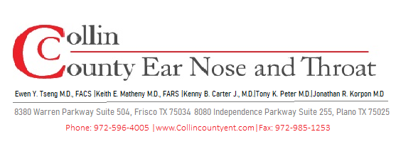
POST-OPERATIVE INSTRUCTIONS
Septoplasty
Surgical Correction of Deviated Nasal Septum

WHAT TO EXPECT AFTER SURGERY

- Nasal packing or internal splints (if placed) will be removed at your first post-op visit — do not remove them yourself.
- Significant nasal congestion and stuffiness is normal and may last 2–4 weeks.
- Mild swelling of the nose and upper lip is common; apply a cold compress (not directly on nose) for comfort.
- Some blood-tinged drainage for the first 24–48 hours is expected — use a folded gauze as a drip pad.
- Improvement in nasal breathing may not be immediately apparent due to swelling — this will resolve.
- Plan for 5–7 days off work; longer for physically demanding jobs.

NASAL CARE

Saline Rinses — Begin Day After Surgery
- Use a saline spray or large-volume rinse 3–4 times daily to keep the septum moist and remove crusting.
- Spray or rinse gently — avoid forceful irrigation for the first week.
- Do NOT blow your nose for the first 2 weeks. If you must sneeze, sneeze with your mouth open.
- Apply a thin layer of saline gel or petroleum jelly inside the nostrils if prescribed for comfort.

ACTIVITY & RESTRICTIONS

OK to Resume  - Light walking day of/after surgery  - Showering (avoid direct water to face) after 24 hrs  - Driving once off narcotic pain medication  - Desk work after 5–7 days | Avoid for 2–3 Weeks  - Blowing nose forcefully  - Heavy lifting or straining (>10 lbs)  - Contact sports or activities risking nasal trauma  - Swimming or submerging face

MEDICATIONS

- Acetaminophen (Tylenol) is the first-line pain medication. Avoid NSAIDs and aspirin for 2 weeks.
- Use prescribed nasal saline spray or rinse as directed.
- If nasal steroid spray was prescribed, begin as directed (usually after first week).
- Complete any prescribed antibiotic course in full.
- Narcotic pain medication: use only as needed, with food, and avoid operating a vehicle.
- Use 2-3 sprays Afrin (oxymetazoline) every 2 hours as needed for bleeding. Max 3 days.

WHEN TO CALL OUR OFFICE

⚠ Contact Us Immediately If You Experience:
- Heavy or persistent bleeding that does not respond to 15–20 minutes of pinching the nose and afrin.
- Dislodged or painful nasal splints/packing.
- Fever over 101.5°F beyond the first 48 hours.
- Severe headache, especially with visual changes or neck stiffness.
- Clear, watery nasal drainage (possible CSF leak).
- Significant facial swelling, bruising, or swelling around the eyes.

FOLLOW-UP CARE

- First post-op visit: 5–7 days after surgery for splint/packing removal and wound check.
- Breathing improvement is typically noticeable within 2–4 weeks as swelling resolves.
- Full healing of the septum takes 3–6 months, though functional improvement is usually evident earlier.
- Septoplasty is sometimes combined with turbinate reduction or sinus surgery — follow all relevant instructions.

Questions or Concerns? We Are Here to Help.
Office/After Hours: 972-596-4005
For emergencies or severe symptoms, go to the nearest Emergency Room.

