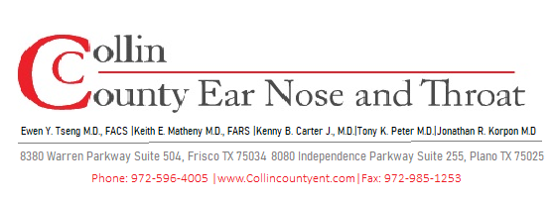
POST-OPERATIVE INSTRUCTIONS
Adenoidectomy
Surgical Removal of the Adenoids

WHAT TO EXPECT AFTER SURGERY

- Mild sore throat and nasal congestion are the most common complaints — usually mild and short-lived.
- Your child's voice may sound nasal or different ("pinched" quality) for 2–6 weeks — this is temporary.
- A low-grade fever under 101°F in the first 24–48 hours is common.
- Some blood-tinged nasal drainage in the first 24 hours is normal.
- Bad breath for 1–2 weeks is expected as the surgical site heals.
- Most children return to school/daycare within 3–5 days; adults within 5–7 days.

DIET & HYDRATION

Keeping Your Child Well Hydrated is the Priority
- Start with cool, clear liquids: water, diluted juice, popsicles, ice chips, broth.
- Advance to soft foods: yogurt, applesauce, pudding, mashed potatoes, scrambled eggs.
- Most children return to a normal diet within 5–7 days.
- AVOID: hot foods or liquids for the first 24 hours, hard or crunchy foods for 1 week.
- AVOID: straws — suction can cause bleeding.
- Encourage fluids frequently — even small amounts help prevent dehydration.

PAIN MANAGEMENT

- Children's acetaminophen (Tylenol) or ibuprofen (Motrin/Advil) as directed for age and weight.
- Give pain medication proactively — don't wait until pain is severe.
- Do NOT give aspirin to children (risk of Reye's syndrome).
- Cool fluids, popsicles, and a cool-mist humidifier can also ease discomfort.

ACTIVITY & RESTRICTIONS

OK to Resume  - Light play at home starting day 1–2  - Short walks outdoors after 2–3 days  - School/daycare after 3–5 days (if fever-free)  - Swimming after 2 weeks | Avoid for 1–2 Weeks  - Strenuous play, running, gymnastics  - Organized sports or contact play  - Large groups (infection risk first week)  - Blowing nose forcefully first week

NASAL CARE

- Use a saline nasal spray 2–3 times daily to keep the nasal passages moist and clear crusting.
- Avoid forceful nose-blowing for the first 5–7 days.

WHEN TO CALL OUR OFFICE

⚠ Contact Us or Go to the ER Immediately For:
- Any bright red bleeding from the nose or mouth.
- Breathing difficulty, choking, or noisy/labored breathing.
- Fever over 102°F that does not respond to acetaminophen.
- Signs of dehydration: no urination for 8+ hours, no tears, extreme fatigue.
- Severe neck stiffness or high fever (rare risk of Grisel syndrome — seek ER care).

Also Contact Our Office For:
- Persistent bad breath beyond 2 weeks.
- Nasal voice that has not improved by 6–8 weeks.
- Concerns about bleeding, pain, or the healing process.

WHAT TO EXPECT LONG-TERM

- Fewer ear infections and nasal/sinus infections are expected following adenoidectomy.
- Improved breathing through the nose and better sleep quality typically follow.
- Post-op visit is scheduled at 1-2 weeks to confirm healing.

Questions or Concerns? We Are Here to Help.
Office/After Hours: 972-596-4005
For emergencies or severe symptoms, go to the nearest Emergency Room.

